Total Scenario - 43

**1. Home page**

1. Check that logo of big basket is as per the expectation or not.
2. Verify that all the links and banners are redirecting to the correct product/category pages and none of the links are broken.
3. Check that user can click on logo or not (logo is clickable or not).
4. Check that after clicking on logo user can move to home page or not.
5. Verify that all the images – product and banner are clearly visible.
6. Check that user can search any product by **search option**
7. Verify that on searching, products get displayed on the basis of their relevancy.
8. Check that user can also search by brand name.
9. Check that user can see selected items in **My Basket option**
10. Verify that the user can add to my basket one or more products.
11. Check that user can see **new launches** item with offer in top of the screen
12. Check that user can see/select category of food items by clicking on SHOP BY CATEGORY. (e.g. Fruits & vegetables, beverages etc…)
13. Check that user can see/select category of category or sub category (e.g Fruits & vegetables -> fresh vegetables, fresh fruits)
14. Check that user can see/select sub category of sub category of all item (e.g Fruits & vegetables -> fresh vegetables, fresh fruits -> Potato, Onion, & Tomato, Leafy vegetables)
15. Check that user can see the offer and even can see which bank has the offer.
16. Check that user can see **Best Sellers** list in home page.

**2. Product module**

1. Verify that category pages have a relevant product listed, specific to the category.
2. Check that user can see image of product.
3. Verify that all the information displayed – product name, category name, price, and product description is clearly visible.
4. Veg or non veg category is mention in product details.
5. Check that user can see name of the product.
6. Check that user can select list of Kg.
7. Check that Price is mention in product details.
8. Check that delivery time is mention is product details.
9. Check that user can select quantity of item.
10. Check that user can see/select ADD TO BASKET button.
11. By clicking on item it move to another screen with more details of related item.
12. There must be details mention in **About the Product** field in bottom of the product.
13. There must be details mention in **Benefits** field in bottom of the product.
14. There must be details mention in **Storage and Uses** field in bottom of the product.
15. There must be details mention in **Other Product Info** field in bottom of the product.
16. There must be details mention in **Variable weight policy** field in bottom of the product.
17. User can **rate and review** the product only after purchasing from bigbasket.
18. Check that **recipes** available with what user can make with this item in bottom of page

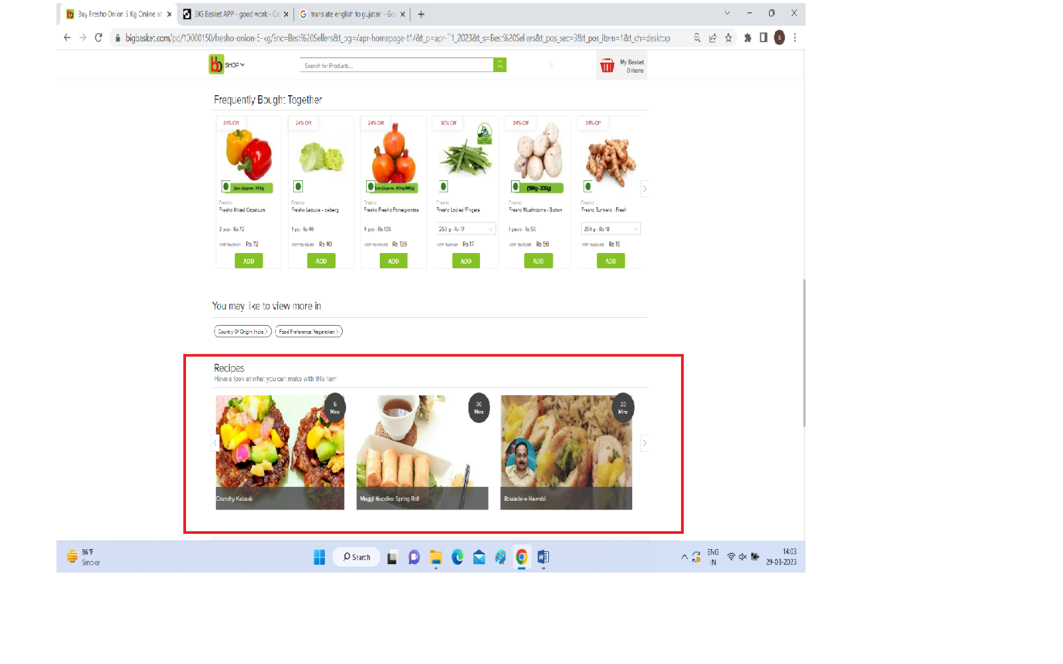

1. Check that **Most Popular** productlist available in home page.

**3. Payment module**

1. Once user add time in basket then click on **View basket & Checkout** button for payment.

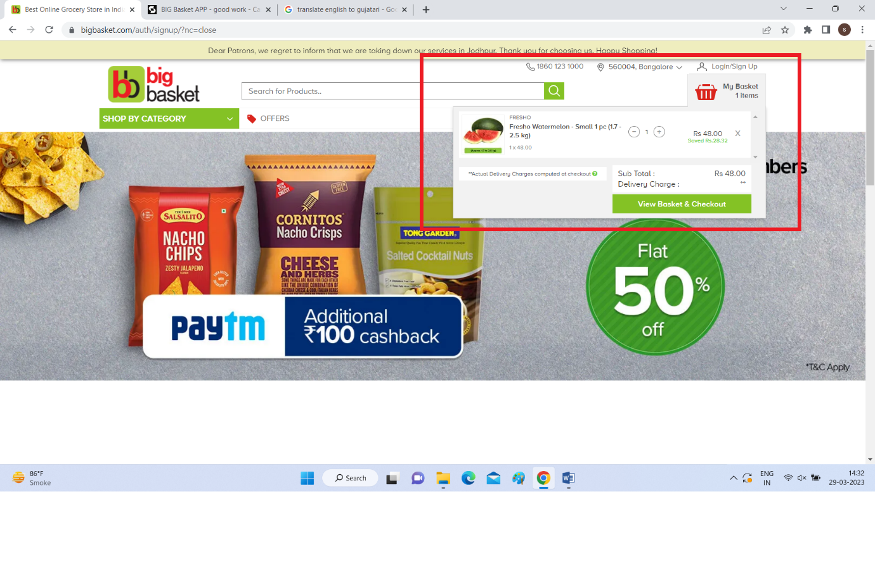

1. Check that if new user clicking on **View basket & Checkout** button than it should show LOGIN/SIGN UP dialogbox.
2. Check that after entering mobile number and click on Signup using OTP button it should send 6-digit TOP.
3. Check that farther it should ask for Name and Email address.
4. Check that it should ask for address at the time of order pace only for first time or new user.
5. Verify that the different prepaid methods of payments are working fine.
6. Verify that the Cash on Delivery option of payment is working fine.
7. Verify that product return functionality works correctly.